7th Lab – Three Way Traffic Light Control Using AT89C51 Microcontroller

Implementation:
Keil:
Open Keil µVision → Go to Project → New µVision Project → Set a project name and save it → In the Select Device for Target window, search and select AT89C51 → Click OK → When prompted, click No → In Project window, right-click Source Group 1 under Target 1 → Select Add New Item to Group 'Source Group 1' → Create and save a new C file → Write the code below and save:
Source Code:
#include <reg51.h>
// Traffic Light 1 (P2.0 - P2.2)
sbit RED_1 = P2^0;
sbit YELLOW_1 = P2^1;
sbit GREEN_1 = P2^2;
// Traffic Light 2 (P2.3 - P2.5)
sbit RED_2 = P2^3;
sbit YELLOW_2 = P2^4;
sbit GREEN_2 = P2^5;
// Traffic Light 3 (P3.0 - P3.2)
sbit RED_3 = P3^0;
sbit YELLOW_3 = P3^1;
sbit GREEN_3 = P3^2;
void delay(unsigned int t)
{
unsigned int i, j;
for(i = 0; i < t; i++)
for(j = 0; j < 1275; j++);
}
// Phase 1: 1 - RED, 2 - YELLOW, 3 - GREEN
void signal_phase1()
{
RED_1 = 1; YELLOW_1 = 0; GREEN_1 = 0;
RED_2 = 0; YELLOW_2 = 1; GREEN_2 = 0;
RED_3 = 0; YELLOW_3 = 0; GREEN_3 = 1;
delay(200);
}
// Phase 2: 1 - GREEN, 2 - RED, 3 - YELLOW
void signal_phase2()
{
RED_1 = 0; YELLOW_1 = 0; GREEN_1 = 1;
RED_2 = 1; YELLOW_2 = 0; GREEN_2 = 0;
RED_3 = 0; YELLOW_3 = 1; GREEN_3 = 0;
delay(200);
}
// Phase 3: 1 - YELLOW, 2 - GREEN, 3 - RED
void signal_phase3()
{
RED_1 = 0; YELLOW_1 = 1; GREEN_1 = 0;
RED_2 = 0; YELLOW_2 = 0; GREEN_2 = 1;
RED_3 = 1; YELLOW_3 = 0; GREEN_3 = 0;
delay(200);
}
// Sequence control
void traffic_light_sequence()
{
signal_phase1();
signal_phase2();
signal_phase3();
}
void main()
{
P1 = 0x00;
P2 = 0x00;
P3 = 0x00;
while(1)
{
traffic_light_sequence();
}
}
→ Right-click Source Group 1 → Add Existing Files to Group → Select the saved .c file → Click Add and Close → Right-click Target 1 → Options for Target → Go to Output tab → Check "Create Hex File" → Go to Target tab → Set Xtal (MHz) to 11.0592 → Click OK → Press F7 to build the project → If there are no errors or warnings, your code is okay.

Proteus:
Open Proteus → Click New Project → Set project name → Keep clicking Next until Finish → Click Finish → From the left sidebar, select Component Mode → Click P → Search and add AT89C51 → Add Traffic Lights
Component Placement:
Place U1 (AT89C51) on the workspace → Place Traffic Lights on three sides (each with 3 LEDs: Red, Yellow, Green)
Wiring:
- Traffic Light 1:
  - P2.0 → Red
  - P2.1 → Yellow
  - P2.2 → Green
- Traffic Light 2:
  - P2.3 → Red
  - P2.4 → Yellow
  - P2.5 → Green
- Traffic Light 3:
  - P3.0 → Red
  - P3.1 → Yellow
  - P3.2 → Green
Programming:
Double-click U1 → Set clock frequency = 11.0592MHz → Browse and select the U1 HEX file generated from Keil → Click OK
Simulation:
Click the Play button → If Traffic Lights blink correctly in the 3-way sequence (RED – YELLOW – GREEN cycling between directions), your setup is working → Save the project
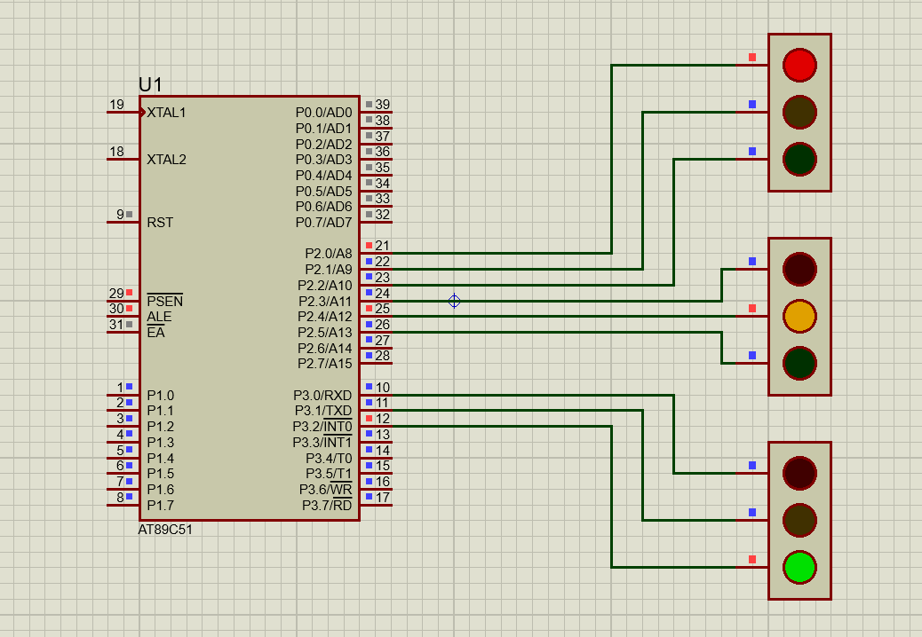
Diagram:

